BANSAL COLLEGE OF ENGINEERING
MANDIDEEP


A
MINOR PROJECT REPORT
ON
“BUS TICKET MANAGEMENT SYSTEM”

Submitted in partial fulfillment of Bachelor of Engineering Degree in Computer Science & Engineering
of

RAJIV GANDHI PROUDYOGIKI VISHWAVIDYALAY
BHOPAL


Submitted By:

AKSHAT SHUKLA (0127CS211008)
CHETAN DONIWAL (0127CS211024)
MOHIT KUMAR PATEL (0127CS211050)
NEELAM JANYANI (0127CS211053)

Session 2023 - 2024

BANSAL COLLEGE OF ENGINEERING MANDIDEEP

(COMPUTER SCIENCE & ENGINEERING)

CERTIFICATE

This is to certify that project report entitled “BUS TICKET MANAGEMENT SYSTEM” presented by AKSHAT SHUKLA, CHETAN DONIWAL, MOHIT KUMAR PATEL and NEELAM JANYANI is the bonafide presentation of the work done by them under my supervision and guidance. The project report has been submitted towards partial fulfillment for the award of degree of Bachelor of Engineering of Rajiv Gandhi Prodyogiki Vishwavidyalaya, Bhopal during the academic year 2023-24. It is further certified that this work has not been submitted elsewhere for the award of any degree or diploma.

Approved By  (Prof. Sunil Kumar)  HOD  Department of CSE |  | Guided By  (Dr. Kusum Lata)  Asst. Prof. (CSE)  Department of CSE
(Dr. R. Rawat)
Director, BCE Mandideep

Project Title

OUR GROUP MEMBERS:
1. AKSHAT SHUKLA (0127CS211008)
2. CHETAN DONIWAL (0127CS211024)
3. MOHIT KUMAR PATEL (0127CS211050)
4. NEELAM JANYANI (0127CS211053)

CONTRIBUTION IN THE PROJECT:

- AKSHAT SHUKLA – Akshat Shukla build front-end of the website using HTML, CSS, JS along with Chetan Doniwal.

- CHETAN DONIWAL – Chetan Doniwal build front-end of the website using HTML, CSS, JS along with Akshat Shukla.

- MOHIT KUMAR PATEL – Mohit Kumar Patel build back-end of the website using Express JS, Mongo DB, and other Node JS libraries.

- NEELAM JANYANI – Neelam Janyani worked on UI design of the website and documentation of the project.

INDEX
CONTENTS | PAGES NO.
- INTRODUCTION | 1
- LITERATURE SURVEY | 2
- SYSTEM REQUIREMENT  - HARDWARE REQUIREMENT  - SOFTWARE REQUIREMENT | 3
- TOOLS/TECHNOLOGY USED  - TOOLS  - TECHNOLOGY | 4-6
- SOFTWARE MODEL USED | 7-8
- SYSTEM DESIGN  - DATA FLOW DIAGRAMS  - CONTROL FLOW DIAGRAM | 9
- TESTING | 10-11
- SNAPSHOTS  - HOME PAGE  - LOGIN FORM PAGE  - SINUP FORM PAGE  - ADMIN PAGE  - PASSENGER PAGE  - TICKETS PAGE  - CONTACT US PAGE  - BUSES PAGE | 12-16
- CODING  - INDEX.HTML  - STYLE.CSS  - SCRIPT.JS  - DB.JS  - CREATEBUS.JS  - CREATESEATSELECTIONMODAL.JS | 17-25
- CONCLUSION | 26
- FUTURE ENHANCEMENTS | 27
12. REFRENCES | 28

- INTRODUCTION

In the fast-paced world of transportation, efficient and reliable ticket management is crucial for both operators and passengers. Our project, the Bus Ticket Management System, aims to
streamline and modernize the process of booking and managing bus tickets. This web-based solution provides a user-friendly platform for passengers to book tickets online, while also offering comprehensive management tools for bus operators.

Benefits: -
- Streamlined processes lead to increased operational efficiency for bus operators, reducing manual workload and minimizing errors.
- Passengers can enjoy the convenience of booking tickets from the comfort of their homes or on the go, reducing the need for physical visits to ticket counters.
- The online platform enhances accessibility for a broader audience, allowing passengers from various locations to access and use the service.
- Robust security measures protect user data, ensuring the confidentiality and integrity of personal information and financial transactions.
- .

- LITERATURE SURVEY
Year |  | Author | Title | Functionality | Result
2014 |  | Oloyede, M.O., Alaya, S.M. and Adewole, K.S. | Development of an Online Bus Ticket Reservation System for a Transportation Service in Nigeria | Most commonly used user activities and admin activities. | Created these functionalities in the website.
2020 |  | Harshit Jadon | Bus Ticket Management System | Analyzing the data flow diagram of this website. | Created the data flow diagram of our website.

3. SYSTEM REQUIREMENT
3.1 HARDWARE REQUIREMENTS
- Processor CPU with 1.7GHz & above Frequency
- RAM 2GB RAM or above
- Min Hard Disk- 20 GB
3.2 SOFTWARE REQUIREMENTS
- Node JS
- Mongo DB
- NPM
- Internet Connection

4. TOOLS/TECHNOLOGY USED
4.1 TOOLS
4.1.1 FRONT END
- HTML
- CSS
- JavaScript

4.1.2 CONNECTIVITY
- Node JS
- Mongo DB
- Internet Connection
4.1.3 SOFTWARE USED
- Visual Studio Code
- Google chrome
- Mongo DB Compass

4.2 TECHNOLOGY

- CSS
Cascading Style Sheets, fondly referred to as CSS, is a simply designed language intended to simplify the process of making web pages presentable. CSS allows you to apply styles to web pages. More importantly, CSS enables you to do this independent of the HTML that makes up each webpage. CSS is easy to learn and understand, but it provides powerful control over the presentation of an HTML document.
- JavaScript
JavaScript is the world most popular lightweight, interpreted compiled programming language. It is also known as scripting language for web pages. It is well-known for the development of web pages, many non-browser environments also use it. JavaScript can be used for Client-side developments as well as Server-side developments.
- HTML
HTML stands for HyperText Markup Language. It is used to design web pages using a markup language. HTML is the combination of Hypertext and Markup language. Hypertext defines the link between the web pages. A markup language is used to define the text document within tag which defines the structure of web pages.
HTML is a markup language that is used by the browser to manipulate text, images, and other content to display in the required format.
- Visual-Studio-Code
Visual Studio Code is a source-code editor made by Microsoft for Windows, Linux and macOS.[9] Features include support for debugging, syntax highlighting, intelligent code completion, snippets, code refactoring, and embedded Git. Users can change the theme, keyboard shortcuts, preferences, and install extensions that add additional functionality.
- NodeJS
Node.js is an open-source, cross-platform JavaScript runtime environment that enables the execution of JavaScript code server-side. It is designed to build scalable network applications and is particularly well-suited for building web applications and APIs. Node.js is based on the V8 JavaScript runtime engine, which is developed by Google for use in the Chrome browser.
- MongoDB
MongoDB is a popular, open-source NoSQL database management system designed to store, retrieve, and manage document-oriented data. Unlike traditional relational databases, MongoDB uses a flexible, schema-less document model that allows developers to work with data in a more natural and intuitive way. MongoDB is part of the family of databases classified as NoSQL databases, which provide a more flexible approach to data storage and retrieval.

5. SOFTWARE MODEL USED
5.1 Prototyping Model
The Prototyping Model typically involves the following phases:

- Requirements Gathering: Collecting and understanding the requirements from stakeholders.
- Quick Design: Creating a basic design or outline based on initial requirements.
- Prototype Development: Building a prototype based on the quick design, usually with limited functionality.
- Prototype Evaluation: Testing and gathering feedback on the prototype from stakeholders, users, or clients.
- Refinement: Incorporating feedback and making necessary improvements to the prototype.
- Final Implementation: Developing the final product based on the refined prototype, often iteratively incorporating additional features and enhancements.

These phases may vary slightly depending on the specific project and requirements, but they form the core steps of the Prototyping Model.

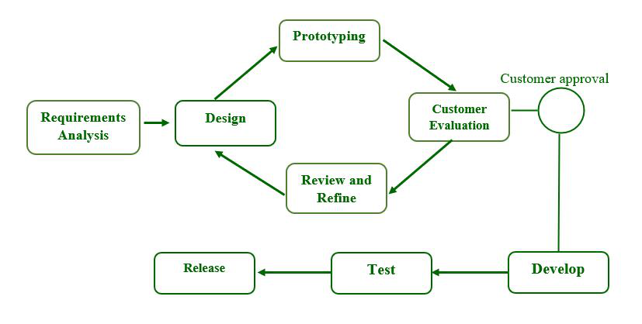
Fig. 5.1 Prototyping Model
Advantages
- Users help to shape the future. As a result, errors can be discovered during the first stage of the software development process.
- Prototyping is also considered a risk reduction function because it allows non-existent performance to be seen, lowering the risk of failure.
- Assists team members in effectively communicating.
- Customer satisfaction exists, and he can feel the product from the start.
- There will be no risk of software loss.
- Quick user feedback aids in the development of better software solutions

Disadvantages
- Prototyping is a time-consuming and labor-intensive process.
- The cost of creating a specific type of waste is completely wasted because the prototype is eventually discarded.
- Prototyping may result in an overabundance of change requests.
- Customers may be unwilling to commit to the iteration cycle for an extended period.
- During each customer test, there may be too many variations in software requirements.
- Poor documentation because of changing customer needs.

6. SYSTEM DESIGN
6.1 Data Flow Diagram
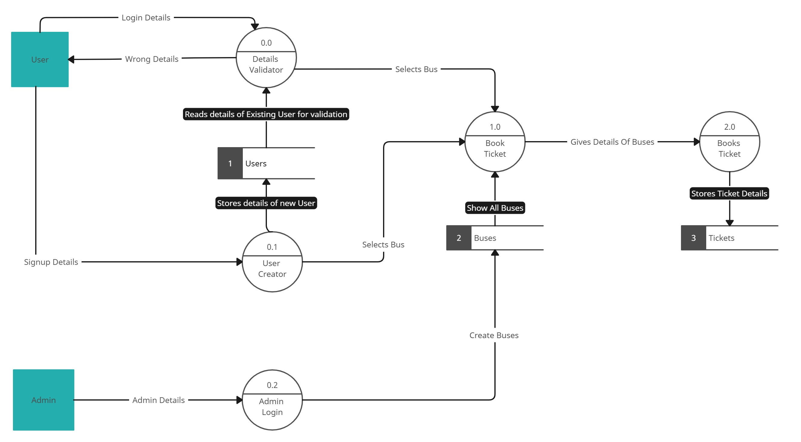Fig. 6.1 Data Flow Diagram
6.2 ER Diagram

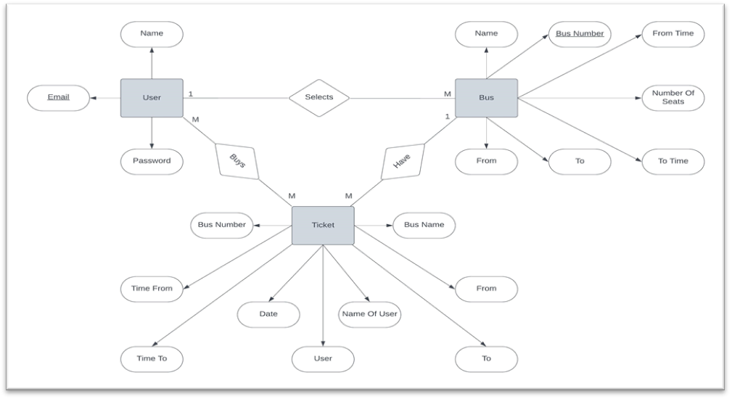
Fig. 6.2 ER diagram

7. TESTING
Unit Testing is a level of software testing where individual unity components of a software are tested. The purpose is to validate that each unit of the software performs as designed. A unit is the smallest testable part of any software. It usually has one or a few inputs and usually a single output. In procedural programming, a unit may be an individual program, function, procedure, etc. In object-oriented programming, the smallest unit is a method, which may belong to a base super class, abstract class of derived child class. (Some treat a module of an application as a unit: This is to be discouraged as there will be many individual units within those modules. Unit testing frameworks, drivers, stubs, and mock/ fake objects are used to assist in unit testing.
Unit Testing Tips:
- Find a tool framework for your language. Do not create test cases for everything. Instead, focus on the tests that impact the behavior of the system. Isolate the development environment from the test environment.
- Use test data that is close to that of production.
- Before fixing a defect, write a test that exposes the defect. Why? First, you will later be able to catch the defect if you do not fix it properly. Second, your test suite is now more comprehensive. Third, you will most probably be too lazy to write the test after you have already fixed the defect. Write test cases that are independent of each other. For example, if a class depends on a database, do not write a case that interacts with the database to test the class. Instead, create an abstract interface around that database connection and implement that interface with a mock object.
- Aim at covering all paths through the unit. Pay particular attention to loop conditions.
- Make sure you are using a version control system to keep track of your test scripts. In addition to writing cases to verify the behaviour, write cases to ensure the performance of the code.
- Perform unit tests continuously and frequently.

7.1 Integration testing
Integration testing is a level of software testing where individual units are combined and tested as a group. The purpose of this level of testing is to expose faults in the interaction between integrated units. Test drivers and test stubs are used to assist in Integration Testing Integration testing. Testing was performed to expose defects in the interfaces and in the interactions between integrated components or systems. See also component integration testing, system integration testing.
7.2 Component Integration Testing
Testing was performed to expose defects in the interfaces and interaction between integrated components system integration testing. Testing the integration of systems and packages testing interfaces to external organizations (eg. Electronic Data Interchange, Internet) that you have a proper Detail Design document where interactions between each unit are clearly defined. In fact, you will not be able to perform Integration Testing without this information:
Ensure that you have a robust Software Configuration Management system in place. Or else, you will have a tough time tracking the right version of each unit, especially if the number of units to be integrated is huge. Make sure that each unit is unit tested before you start Integration Testing. As far as possible, automate your tests, especially when you use the Top Down or Bottom-Up approach, since regression testing is important each time you integrate a unit, and manual regression testing can be inefficient.
7.3 Functional testing
It is a type of software testing whereby the system is tested against the functional requirements specifications. Functions (or features) are tested by feeding them input and examining the output. Functional testing ensures that the requirements are properly satisfied by the application. This type of testing is not concerned with how processing occurs, but rather, with the results of processing. It simulates actual system usage but does not make any system structure. This type of testing is not concerned with how processing occurs, but rather, with the results of processing. It simulates actual system usage but does not make any system structure assumptions.
During functional testing, Black Box Testing technique is used in which the internal logic of the system being tested is not known to the tester Functional testing is normally performed during the levels of Systems Testing and Acceptance Testing.

8. SNAPSHOTS
8.1 HOME PAGE
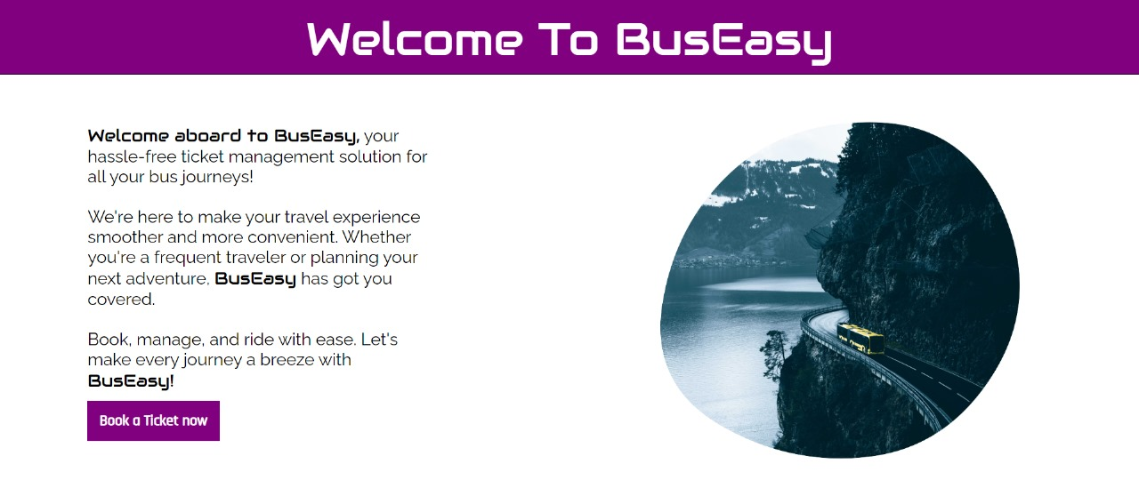
Fig. 8.1 Home Page
8.2 LOGIN FORM PAGE
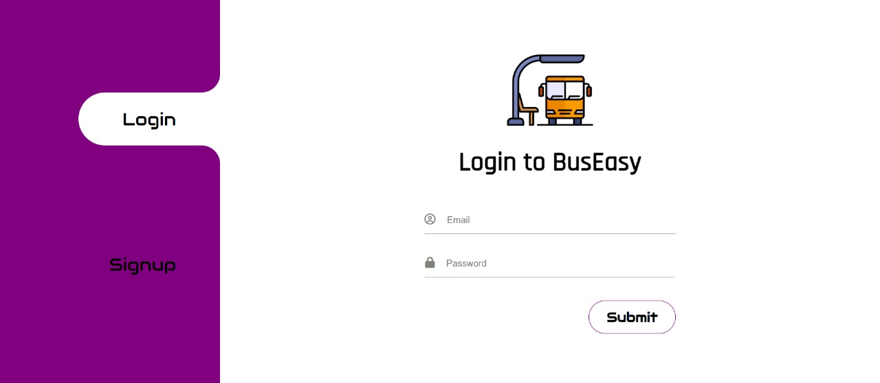
Fig. 8.2 Login form

8.3 SIGNUP FORM PAGE
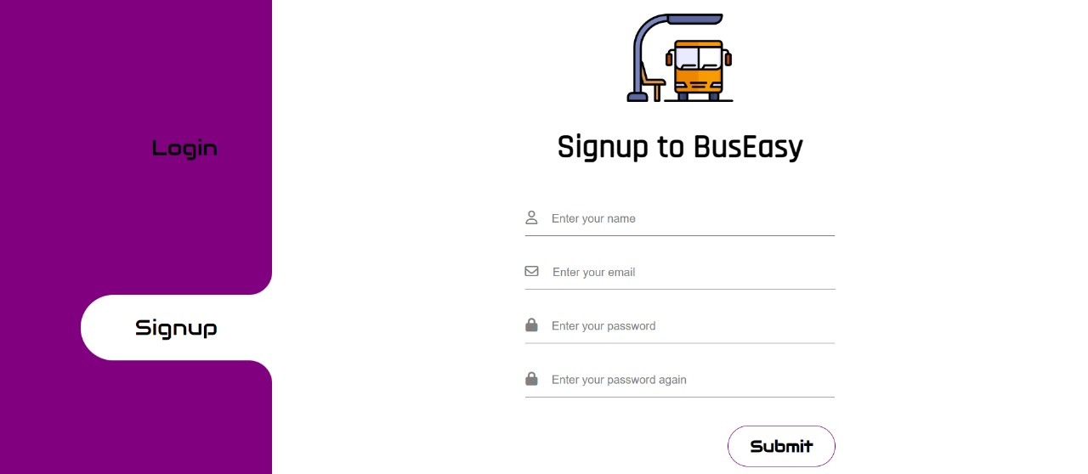Fig. 8.3 Signup form
8.4 ADMIN PAGE
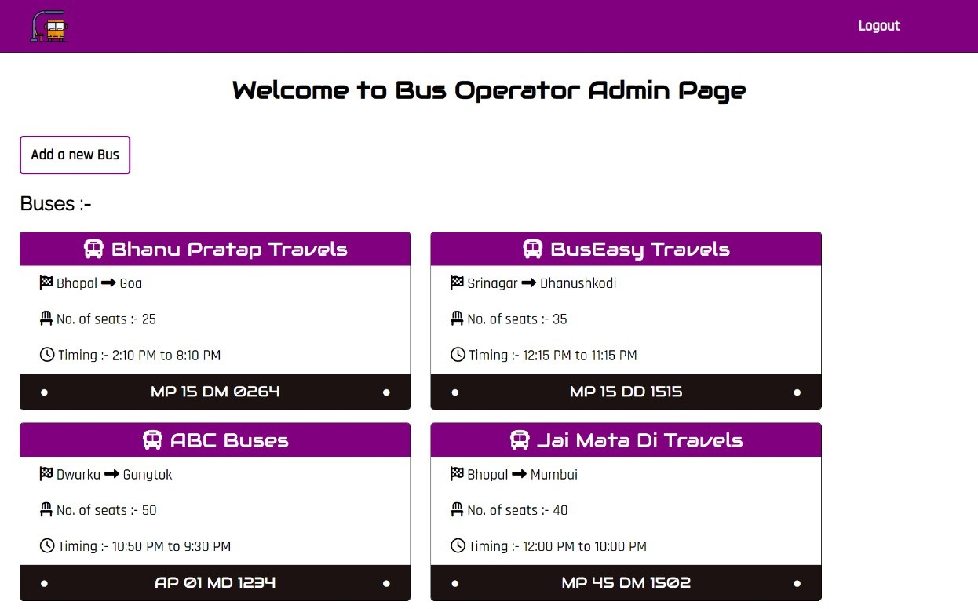
Fig. 8.4 Admin page

8.5 PASSENGERS PAGE
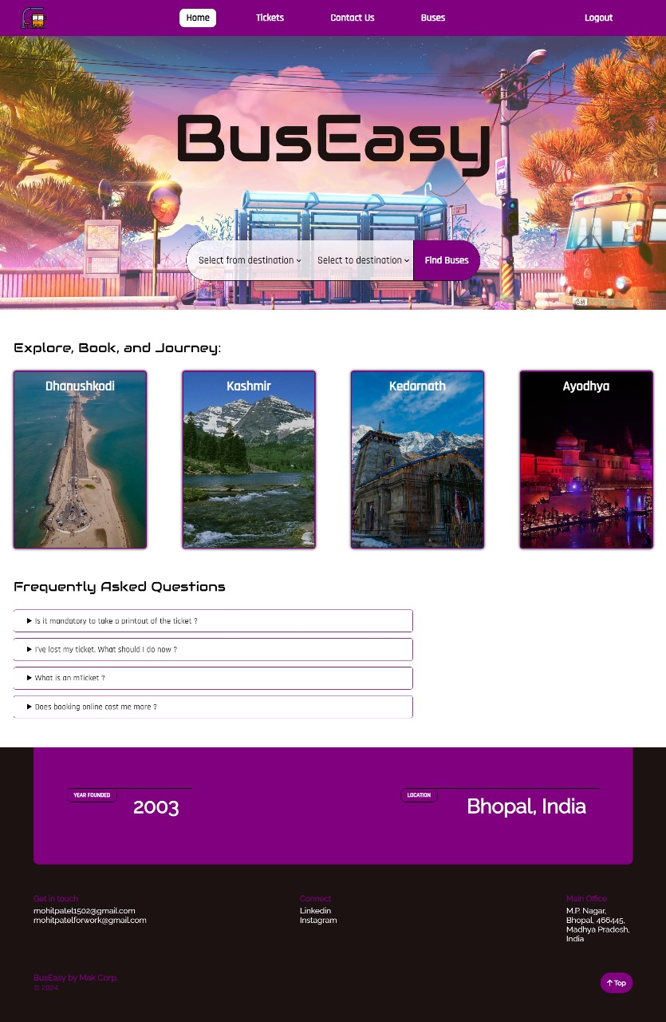Fig. 8.5 Passenger page
8.6 TICKETS PAGE
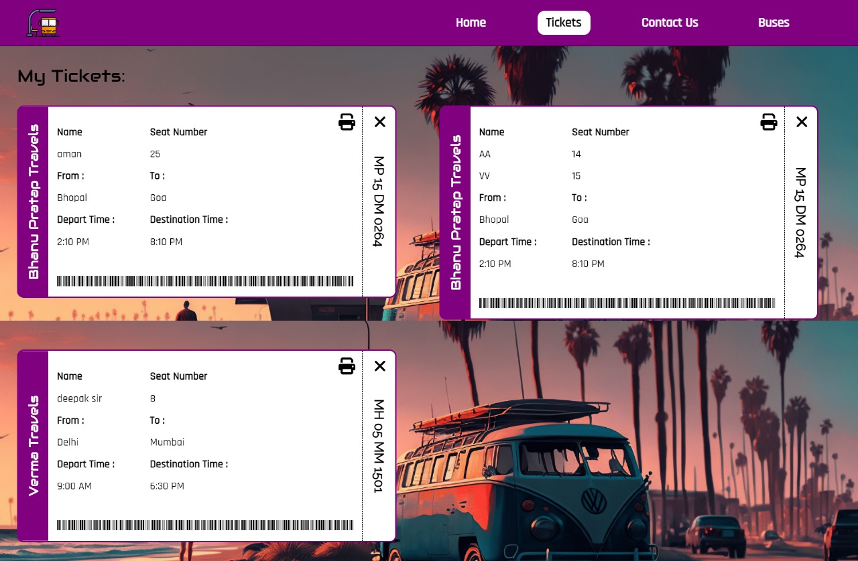Fig. 8.6 Tickets page
8.7 CONTACT US PAGE
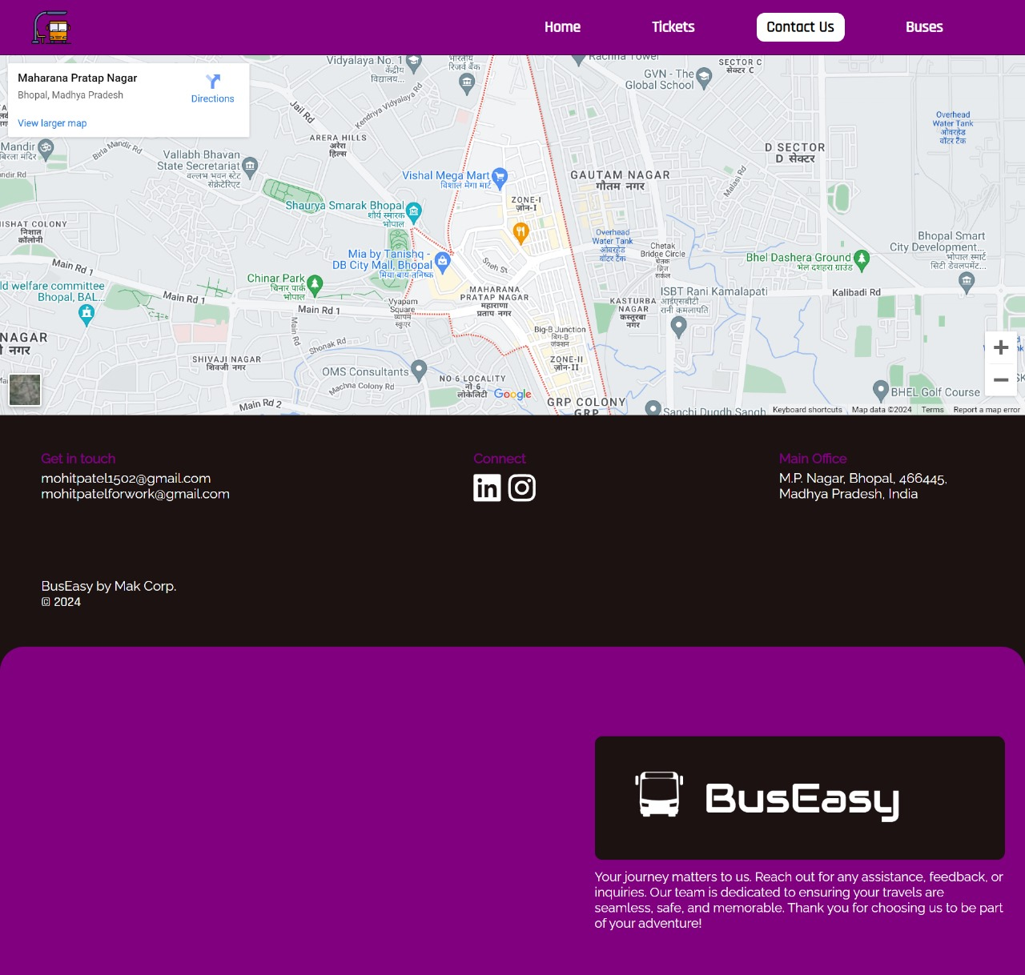
Fig. 8.7 Contact us page.
8.8 BUSES PAGE
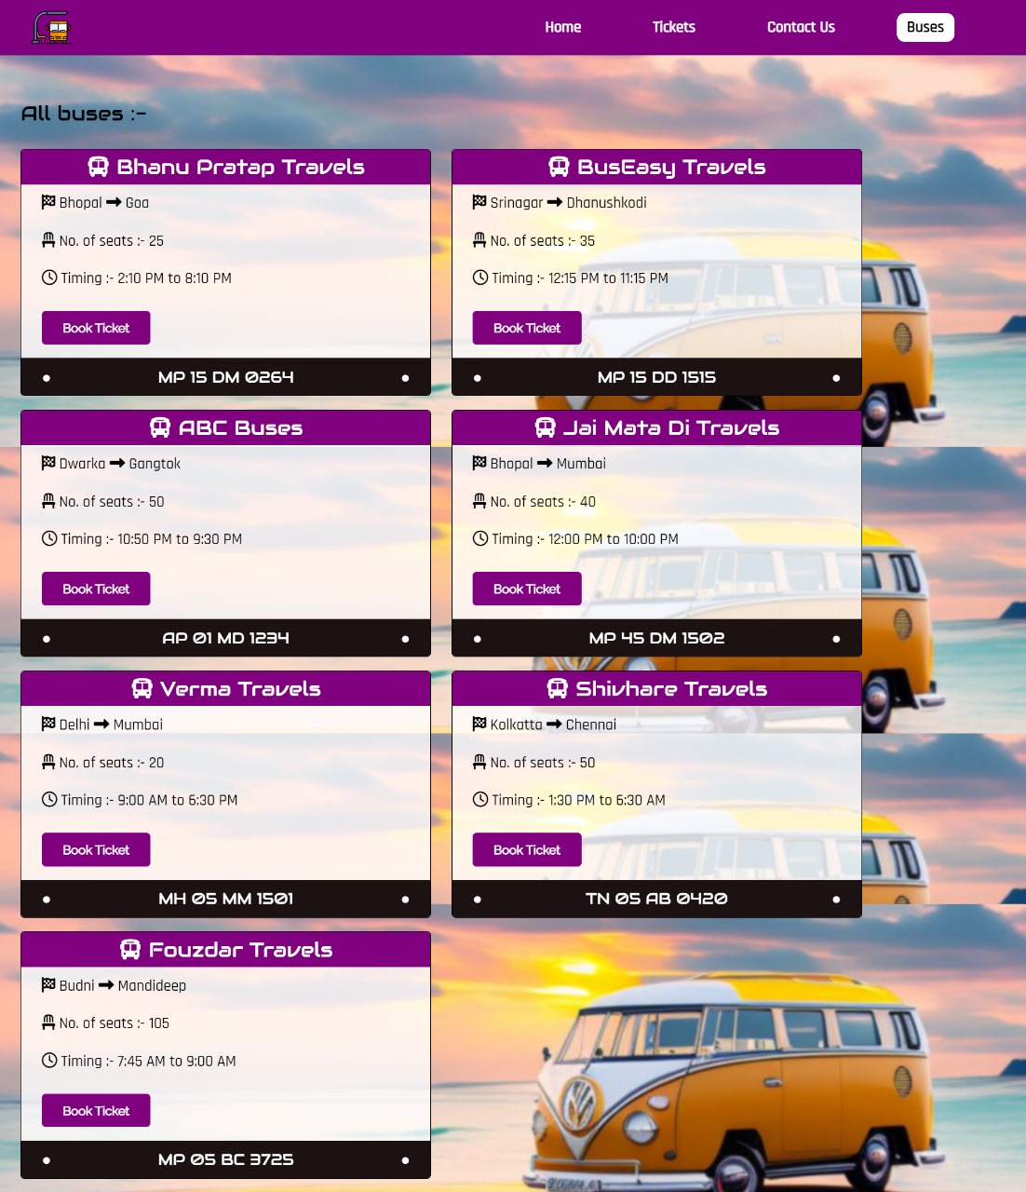
Fig. 8.8 Buses page

9. CODING

Ther main files in our project are :
- index.html
- style.css
- script.js
- db.js
- createBus.js
- createSeatSelectionModal.js

- index.html

<html lang="en">

<head>
<meta charset="UTF-8">
<meta name="viewport" content="width=device-width, initial-scale=1.0">
<title>BusEasy</title>
<link rel="icon" href="./assets/title-logo.png" type="image/icon">
<link rel="stylesheet" href="css/style.css">
</head>

<body>
<div class="heading">
<h1>Welcome To BusEasy</h1>
</div>
<div class="container">
<div class="welcome-text">
<strong>Welcome aboard to BusEasy,</strong> your hassle-free ticket management solution for all your bus
journeys! <br><br>
We're here to make your travel experience smoother and more convenient. Whether you're a frequent traveler
or planning your next adventure, <strong>BusEasy</strong> has got you covered. <br><br>
Book, manage, and ride with ease. Let's make every journey a breeze with <strong>BusEasy!</strong><br><br>
<a href="login.html">Book a Ticket now</a>
</div>
<div class="blob">
<img src="assets/home-blob-img.jpg" alt="">
</div>
</div>
<script src="js/script.js" defer></script>
</body>

</html>

- style.css

/* IMPORT STATEMENTS */
@import url("https://fonts.googleapis.com/css2?family=Audiowide&family=Rajdhani:wght@500&family=Raleway&display=swap");

* {
margin: 0;
padding: 0;
box-sizing: border-box;
}

body {
overflow: hidden;
}
.heading {
height: 15vh;
background: purple;
border-bottom: 1px solid black;
color: white;
}
h1 {
padding: 2vh 0;
font-family: "Audiowide", sans-serif;
font-size: 4vmax;
font-weight: 100;
text-align: center;
}
.container {
display: flex;
justify-content: space-around;
height: 85vh;
}
.welcome-text{
padding: 10vh 0;
font-family: 'Raleway';
font-size: 1.5vmax;
width: 30vw;
}

.welcome-text strong{
font-family: 'Audiowide' , sans-serif;
font-weight: 100;
}

.welcome-text a{
border: none;
background-color: purple;
color: white;
text-decoration: none ;
padding: 2vh 1vw;
font-family: 'Rajdhani' , sans-serif;
font-weight: 700;
font-size: 1.3vmax;
position: relative;
border: 1px solid purple;
cursor: pointer;
}

.welcome-text a::before{
content: '';
position: absolute;
bottom: 0;
left: 50%;
width: 0%;
height: 8%;
background: white;
transition: all .3s ease;
}

.welcome-text a:hover::before{
left: 0;
width: 100%;
}
.blob {
overflow: hidden;
display: inline-block;
height: 90vh;
position: relative;
}

.blob img {
width: 100%;
height: 100%;
mask-image: url("../assets/home-page-blob.png");
-webkit-mask-image: url("../assets/home-page-blob.png");
mask-repeat: no-repeat;
-webkit-mask-repeat: no-repeat;
mask-size: contain;
-webkit-mask-size: contain;
object-fit: cover;
transition: all .3s ease-in-out;
}

- script.js

window.addEventListener('load' , () => {
setTimeout(() => {
window.location.replace("login.html");
}, 7500);
})

- db.js

const mongoose = require('mongoose');
const URL = "mongodb://127.0.0.1:27017/busdb";

const DBConnect = async () => {
try {
await mongoose.connect(URL).then(() => {
console.log('Database connected');
})

} catch (error) {
console.log(error);
}
}
module.exports = DBConnect;

- createBus.js

import { showAndSelectSeatModal } from './createSeatSelectionModal.js';

export function createBus(
container,
name,
fromLoc,
toLoc,
numOfSeats,
fromTime,
toTime,
number,
seatAllocatedArr
) {
let bus = document.createElement("div");
let nameDiv = document.createElement("div");
let fromAndToLocDiv = document.createElement("div");
let numOfSeatsDiv = document.createElement("div");
let fromAndToTimeDiv = document.createElement("div");
let numberDiv = document.createElement("div");
let bookTicketBtn = document.createElement("button");

bus.classList.add("bus");
nameDiv.classList.add("bus-name");
fromAndToLocDiv.classList.add("start-end-pos");
numOfSeatsDiv.classList.add("seat");
fromAndToTimeDiv.classList.add("timing");
numberDiv.classList.add("number-plate");
bookTicketBtn.classList.add("book-ticket");

// CODE FOR BOOKING A TICKET FOR THIS BUS
bookTicketBtn.addEventListener("click", async () => {
let seatModalSection = document.querySelector('.modalForSeatSelection');
showAndSelectSeatModal(seatModalSection, number, numOfSeats, seatAllocatedArr);
});

nameDiv.innerHTML = `<i class="fa-solid fa-bus"></i><span> ${name}</span>`;
fromAndToLocDiv.innerHTML = `<i class="fa-solid fa-flag-checkered"></i><span> ${fromLoc}</span> <i class="fa-solid fa-right-long"></i><span> ${toLoc}</span>`;
numOfSeatsDiv.innerHTML = `<i class="fa-solid fa-chair"></i><span> No. of seats :- ${numOfSeats}</span>`;
fromAndToTimeDiv.innerHTML = `<i class="fa-regular fa-clock"></i><span> Timing :- ${fromTime} to ${toTime}</span>`;
numberDiv.innerHTML = `<span>&#9679;</span><span>${number}</span><span>&#9679;</span>`;
bookTicketBtn.innerHTML = `Book Ticket`;

bus.append(
nameDiv,
fromAndToLocDiv,
numOfSeatsDiv,
fromAndToTimeDiv,
bookTicketBtn,
numberDiv
);
container.append(bus);
}

- createSeatSelection.js

export function showAndSelectSeatModal(container, busNumber, totalSeats, seatArray) {
let dialogIdDiv = document.createElement('div');
let h1Dialog = document.createElement('h1');
let form = document.createElement('form');
let section1 = document.createElement('section');
let section2 = document.createElement('section');
let mainDivOfSection1 = document.createElement('div');
let twoSeatDiv = document.createElement('div');
let threeSeatDiv = document.createElement('div');
let h3Section1 = document.createElement('h3');
let btnRightSection1 = document.createElement('button');
let btnSubmitSection2 = document.createElement('button');
let btnLeftSection2 = document.createElement('button');
let busImage = document.createElement('img');
let closeModalBtn = document.createElement('button');

dialogIdDiv.id = 'dialog';
twoSeatDiv.classList.add('two-seat-row');
threeSeatDiv.classList.add('three-seat-row');
btnRightSection1.classList.add('section-nav-btn');
btnRightSection1.classList.add('right-section-btn');
btnLeftSection2.classList.add('section-nav-btn');
btnLeftSection2.classList.add('left-section-btn');
closeModalBtn.classList.add('closeModalBtn');

for (let i = 1; i <= totalSeats; i++) {
let seatCheckBox = document.createElement('input');
seatCheckBox.type = 'checkbox';
seatCheckBox.name = `${i}`;

if (seatArray.indexOf(i) != -1) {
seatCheckBox.disabled = true;
seatCheckBox.title = "Not Available";
}

if (i % 5 === 1 || i % 5 === 2) {
twoSeatDiv.append(seatCheckBox);
}
else if (i % 5 === 3 || i % 5 === 4 || i % 5 === 0) {
threeSeatDiv.append(seatCheckBox);
}
}

h1Dialog.innerHTML = "Select Seats :";
h3Section1.innerHTML = "No. of selected Tickets : <span class='no-of-select-seat'>0</span>";
btnRightSection1.type = 'button';
btnRightSection1.innerHTML = '<i class="fa-solid fa-angle-right"></i>';
btnSubmitSection2.type = "submit";
btnSubmitSection2.innerHTML = "Confirm Ticket";
btnLeftSection2.type = 'button';
btnLeftSection2.innerHTML = '<i class="fa-solid fa-angle-left"></i>';
busImage.src = 'assets/bus-side-view-icon.svg';
closeModalBtn.innerHTML = '<i class="fa-regular fa-circle-xmark"></i>';

mainDivOfSection1.append(twoSeatDiv, threeSeatDiv);
section1.append(mainDivOfSection1, h3Section1, btnRightSection1);
section2.append(btnSubmitSection2, btnLeftSection2);
form.append(section1, section2);
dialogIdDiv.append(h1Dialog, form);
container.append(dialogIdDiv, busImage, closeModalBtn);

container.style.display = 'flex';

closeModalBtn.addEventListener('click', () => {
dialogIdDiv.remove();
busImage.remove();
closeModalBtn.remove();
container.style.display = 'none';
})
let selectedSeats = 0;
const noOfSelectSeat = document.querySelector('.no-of-select-seat');
let busSelectSeats = document.querySelectorAll('#dialog input[type="checkbox"]');

busSelectSeats.forEach((elem) => {
elem.addEventListener('change', () => {
if (elem.checked)
noOfSelectSeat.innerText = ++selectedSeats;
else
noOfSelectSeat.innerText = --selectedSeats;
})
})
btnRightSection1.addEventListener('click', () => {
form.style.transform = "translate(-35vw)";
for (let i = selectedSeats; i >= 1; i--) {
let temp = document.createElement('input');
temp.type = 'text';
temp.required = true;
temp.placeholder = `Enter the name of person ${i}`;
section2.prepend(temp);
}
})
btnLeftSection2.addEventListener('click', () => {
form.style.transform = "translate(0)";
let tempInputTags = section2.querySelectorAll('input[type="text"]');
tempInputTags.forEach((elem) => {
section2.removeChild(elem);
})
})
form.addEventListener('submit', async (e) => {
let seatArrOfBus = [];
let usersArr = [];
e.preventDefault();
let allSeatsInput = document.querySelectorAll('.two-seat-row input, .three-seat-row input');
allSeatsInput.forEach((elem) => {
if (elem.checked === true) seatArrOfBus.push(elem.name - '0');
})
if (seatArrOfBus.length === 0) {
alert('Please select seats');
return;
}
let allNameInputs = section2.querySelectorAll('input[type="text"]');
allNameInputs.forEach((elem) => {
usersArr.push(elem.value);
})
let passwordOfCurrUser = prompt('Enter Your Password');
if (passwordOfCurrUser === null) { }
else if (passwordOfCurrUser.trim() === "") alert('Enter your password')
else {
fetch("http://localhost:3000/ticket/bookticket", {
method: "POST",
headers: {
"Content-Type": "application/json",
"auth-token": localStorage.getItem("token"),
},
body: JSON.stringify({
nameOfUsers: usersArr,
seats: seatArrOfBus,
busNumber: busNumber,
userPassword: passwordOfCurrUser,
}),
})
.then((response) => {
return response.json();
})
.then((data) => {
alert(data.msg);
if(data.msg === 'Ticket Booked Successfully!!'){
window.location.reload();
}
})
.catch((err) => {
alert(`Internal Server Error : ${err.message}`);
});
}
})
}

10. CONCLUSION
Conclusion Points for the Bus Easy Project:

- Bus Easy simplifies public transportation booking, mirroring Red Bus's user-friendly approach and making travel more accessible.

- By digitizing ticketing and scheduling, Bus Easy streamlines operations, reducing manual effort and errors for a smoother experience.

- Like Red Bus, Bus Easy prioritizes customer needs, ensuring a seamless booking process and reliable service to enhance satisfaction.

- Bus Easy showcases the power of technology in improving transit, demonstrating how digital solutions can enhance accessibility and efficiency.

11. FUTURE ENHANCEMENTS
- We will add payment gateway integration to the website.

- We will add functionality for bus operators to add their buses.

- We will make this website mobile supportive also.

- We will give multiple language support option to the user.

- We will make website more secure to prevent any data breach.

- We will make interface more user friendly and more attractive.

12. REFRENCES
- Oloyede, M.O., Alaya, S.M. and Adewole, K.S., 2014. Development of an online bus ticket reservation system for a transportation service in Nigeria. Development, 5(12), pp.40-2.

- Harshit Jadon, “BUS TICKET MANAGEMENT SYSTEM", International Journal of Creative Research Thoughts (IJCRT), ISSN:2320-2882, Volume.8, Issue 7, pp.762-765, July 2020.

- Garg, Nikhil (2024, January 18). How to add HTML and CSS into PDF. GeeksforGeeks. Retrieved from https://www.geeksforgeeks.org/how-to-add-html-and-css-into-pdf/.

- Node Package Manager. (2023). jsonwebtoken. npmjs. Retrieved from https://www.npmjs.com/package/jsonwebtoken

- Node Package Manager. (2024). mongoose. npmjs. Retrieved from https://www.npmjs.com/package/mongoose

- Barbara (2018, November 16). Login UI. Dribble. Retrieved from https://dribbble.com/shots/5559555-Login-UI’

